Standardising guidelines: their creation, distribution, implementation and review in a community setting
Final Stakeholder Report December 2019 – A Narrative - Drs Tom Zamoyski, Catherine Lewis and Helen Ryan
We all want our patients to get care that follows our guidelines that they increasingly are doing together. Partners agreed to support an approach to enable front line out of hospital staff to access standardised guidelines. The subgroup report and recommendations are below.
The project has been supported by the AHSN NENC and the ICS Digital Workstream with a hope other parts of the region might be able to benefit from this. The series of workshops has been very productive and we are now seeking your organisational support to take the enclosed recommendations forward.
We would be grateful if you could confirm your organisations support for the project development. If you or colleagues require any further information please contact julia.newton@ahsn-nenc.org.uk

Recommendations
- Agreement from organisations for the formation of a Guideline Governance Group consisting of; an overall Clinical lead, Librarian, Project manager and supporting clinical leads. Define clear functions in liaison with evolving APC to avoid duplication of work.
- Agreement and engagement from organisations to use the ‘ICP portal’ model of sharing on TeamNet focused at the out of hospital workforce when governance processes are in place. Clarity Informatics are in support of the Single ICP model of sharing and are keen to move forward with this arrangement pending collaboration & agreement from the ICP. (See Appendix 6 for current and proposed sharing models for content)
- Final agreement on job descriptions for new roles and then to advertise/interview for these posts and agree funding streams.
Once up and running:
- Engagement from organisations to populate the future central portal site with shared clinical content as per the proposed Guideline SOP. Ensuring quick wins and links to widely used and desired sites e.g. Networks/APC
- Planned future education/engagement and promotion of new ICP central portal to potential users including health and social care out-of-hospital users, as per Clinical Lead and Librarian role job plans. This will include the dissemination of new clinical content, across one or more CCG areas, using the recognised and most desired local methods of education and engagement, for example CCG bulletins and TITOs.

Introduction
This report details the work that has taken place over the last 7 months from 15th May to 17th December 2019. The project was kindly funded by the AHSN and supported by Newcastle Gateshead CCG and enabled by all partners across the ICP network.
The title above was the original brief of the project; this has been developed further as the project has evolved and stakeholder feedback has been obtained. A workshop in March 2019 recognised that clinicians need fast and easy access to the latest guidelines and local pathways at the click of a button to help enable a reduction in variation of care and ensure the best and equitable use of resources. Currently there is a lack of consistency in guideline and pathway development and sharing. There are several organisations and providers with their own websites and publications; there is no single, central source of information. Newcastle and Gateshead had separate information portals for primary care and information which needs to be shared across multiple areas is often hosted on several platforms which are frequently not up-to-date and difficult to maintain.
Objectives
This project aims to work with local partners to create, distribute, implement and review guidelines across an ICP and for some the ICS footprint if possible.
Progress so far
Teamnet adoption across the ICP. Firstly, all practices and CCGs needed to be on a common platform. Gateshead practices where the only ones not using Clarity Teamnet, so it made sense for them to switch from an in house product to this as their information portal and this was already in use by both North Tyneside and Northumberland CCGs and could therefore be used as a North ICP resource.
Teamnet improvements to create an ICP portal. A large amount of time and work was spent engaging with clarity team net to enable to creation of a central resource with sharing groups enabled across the North ICP. The format and structure of the proposed site has been worked upon to ensure a user-friendly experience. We discussed the best ways of adding clinical content and how this would be identified. The CCG clinical leads were canvassed for advice and provided essential local resources to help populate the site in the future.
Local stakeholders’ engagement. ICP CCGs, Foundation Trusts, CNTW, and partner organisations including APC/MGUG, NECN, NCA and CDRC. As we reached the end of the project there has been interest from others such as the South ICPs and the founder of realgeneralpractice.org to be part of this work.
Organisations represented in process and 3rd Dec Stakeholder next steps meeting:
Newcastle Gateshead CCG | Newcastle upon Tyne Hospitals Foundation Trust | North of Tyne, Gateshead and North Cumbria Area Prescribing Committee
North Tyneside CCG | Gateshead Health Foundation Trust | Northern Cancer Alliance
Northumberland CCG | Northumbria Healthcare Foundation Trust | Clarity Informatics
AHSN | Cumbria, Northumberland, Tyne and Wear Foundation Trust | NHS England and NHS Improvement

Exploration of the future by 3 AHSN clinical leads
After engagement, a process map describing a proposed system has been developed ( appendix 1 ) and this led to the suggestion of new roles for the project including ICP Guidelines Clinical Lead ( appendix 2 ) Librarian ( appendix 3 ) and a Guideline Governance Group (GGG) ( appendix 4 ) to ensure safe, timely review and updating of clinical content on the new ICP central portal. New tools which may help the standardisation of clinical content in the new portal, such as the Guidelines SOP have been developed. (appendix 5)

ICP decision making
An inclusive stakeholder meeting was held on the 3rd December and it was well attended leading to enthusiastic discussion about the project and future direction of travel with broad initial agreement on this. There has been interest from some stakeholders/partner organisations regarding proposed membership of the GGG.
The meeting defined the importance of managing the scope of the project and advised that the initial work could concentrate on collating and hosting existing guidance in one place for out of hospital users rather than creating/overseeing new guidance (too large a remit initially). The group recognised that hosting pathway information was important but that creating new pathways would not be a function of the GGG. It was discussed that it may be more realistic for the organisation that created the guideline to update it with a reliable mechanism to ensure updates are flagged and published on central portal in timely manner.
The difficulty of creating task and finish working groups regionally was recognised and it may be more pragmatic to use one group then have regional sign-off from Consultant expert(s). A problem may be that one group may/will not have sufficient expert opinion for specific guidelines. Debates took place over the need to ensure correct version control and signposting to external websites versus hosting guidelines on the central portal. An issue was raised about concerns re broadband capacity in some practices.
There were comments on the proposed librarian role including that this may work better if embedded in an already existing librarian team rather than isolated working; issues of resilience re broad, complex role. Linkage into the ICS librarian STEM group has been suggested as this may be a source of support/learning and a possible candidate may be sourced for ICP job role; co-ordinator is Joanne Naughton Joanne.Naughton@hee.nhs.uk
Comments about the Guidelines Governance Group included the need to be clear on the proposed membership of the group with broad clinical experience and consider tensions in guideline creation between ‘must haves’ and ‘wish list’. The focus on pre-existing guidelines initially was highlighted and to ‘Pick low-hanging fruits’ initially i.e. make accessible resources which already exist. There was discussion on creating efficient time limited task and finish groups once capacity was available to create new guidelines and how to best identify gaps in guidelines and share content between different CCGs if one CCG has found a solution. There was a discussion of risks including ensuring a watertight Hazard Review process so that guidelines are updated with up to date drug changes, for example MHRA Drug Safety Updates.
The clinical lead role stimulated debate and it was felt that this person would not be best placed to Chair the GGG in order to maintain objectivity/governance. It was felt that a rotating chair may not be best way forward to maintain a consistency of approach and that it would need one person to hold the GGG to account and maintain momentum. It may be best for the chair to be a secondary care clinician who may have influence/strong connections with other secondary care clinicians. The Clinical lead role should hold task and finish groups to account so that work is completed as planned.

Appendix 1 - Process map – page 1
Process map – page 2
Appendix 2 - ICP Clinical Lead Role -Proposed Job Description
Role and Remit
This clinical lead would work ICP wide with Newcastle Gateshead, North Tyneside and Northumberland CCGs to perform the following duties;
A) Could chair the ICP Clinical guidelines governance group and lead/co-ordinate/oversee the task and finish groups. Develop agenda for the CG group and /or Task and finish groups and help prioritise workload of group(s).
B) Work closely with the ICP CG librarian to support content creation and updating/archiving of guidelines/pathways/services/patient resources on the TeamNet portal.
C) Input into appropriate educational and engagement events with the CCGs to support the implementation of new guidelines and pathways.
D) Support N ICP librarian to collate and analyse user feedback about portal content and functioning. Help to create reports for stakeholders about activities/outcomes of the Guideline gov group.

Appendix 3 - Librarian Role for Guidelines project
The proposed banding for this full-time role will be a band 5 with job review after 12 months (likely to be recurrent)
Job Description
Duties and Responsibilities
The post holder is required to participate as a team member of all 3 CCGs across the ICP area incorporating Newcastle, Gateshead, North Tyneside and Northumberland CCGs.
The post holder will work with teams and individuals to perform the following duties:
- Addition of content to populate Clarity TeamNet, clinical and non-clinical, according to the specifications determined by the ICP. This content may vary by CCG area and will require close working with all 3 CCGs and a number of stakeholders.
2. Keeping the Clarity TeamNet central portal up to date by developing links with all relevant stakeholders including primary care, Foundation Trusts, CCG Clinical Leads, Northern Cancer Alliance and Northern England Clinical Network reps etc. This will require the addition of new content and archiving of expired content on the site and highlighting relevant review dates of guidance to the guideline’s governance group for further action.
- To be an active member of the ICP guidelines governance group which will involve:
  - Performing administrative duties for this group including minute taking, preparation of agendas with the group chair and helping to ensure actions are enabled and updated.
  - Managing the NICPCI (North ICP Clinical Information) email account which will act as a central repository for the governance group and guidelines project.
  - Building relationships across the ICP footprint and responding to queries and feedback about Clarity TeamNet and its content from stakeholders and users.
  - Obtaining both formal and informal feedback about how the Clarity TeamNet site is being used from a variety of stakeholders and use this to produce a regular evaluation report and recommendations for improvements.
  - Support the provision of education and engagement activities, including regular stakeholder updates on the progress of the Clarity TeamNet site and actions of the guideline governance group.
  - Discuss, agree, and manage technical priorities and issues about the central portal with the Clarity TeamNet product implementation team.

Working Relationships
The postholder will be required to liaise with the following stakeholders across the ICP area:
CCG Clinical Leads, Medical Directors and primary care reps
Acute Foundation Trusts and NTW
AHSN and NECN reps and NCA where appropriate
Area Prescribing Committee/MGUG

Personal skills required
Previous administrative experience with Clarity TeamNet would be advantageous
Good IT skills
Excellent communication skills
Enthusiasm to work across the ICP area and develop good working relationships
Be able to manage competing priorities and stakeholder expectations

Appendix 4 - Clinical Governance Group Terms of reference
A) Purpose
- Ensure that current guidelines, patient information and service provision information are kept up to date and reviewed in a timely manner. To liaise with the ICP librarian re upcoming review dates of guidance that needs review/action and help provide reports of the actions of the group for wider stakeholders.
- Identify areas of variation/duplication in ICP guidelines which require a consensus view due to conflicting opinions on best care. Ensure such guidelines are reviewed to allow the creation of a single guideline, where possible.
- Overview the creation of new guidelines where none exist or where the evidence is poor, and there is identified need from clinicians and patients to improve quality of care. Identify appropriate task and finish groups for this work.
4) To work with partner organisations to promote further collaboration across the ICS footprint and share learning.
- To take part in evaluations of the clarity TeamNet site and assess how guideline are collated, stored and used, and advise on future improvements.
- Ensure relevant educational events take place to disseminate new guidelines/pathways/service provision and ensure learning is shared across the ICP area.
- To work with the ICP librarian to help develop links with all relevant stakeholders including primary care, foundation trusts, CCG clinical leads, northern cancer alliance and northern England clinical network reps.
B) Remit
To be responsible for the progress of the guidelines project over the ICP footprint and enable task and finish groups when required, to be resourced by the ICP.

C) Proposed Membership
The core membership of the group will consist of:
ICP Guidelines Clinical lead and librarian
CCG clinical leads, Medical Directors
Medicines optimisation pharmacists (NECS)
Acute foundation trusts Medical Director/Clinical Director or designated representative, NTW representative
Other interested parties may include: Clarity Teamnet rep, CDRC rep, NECN and NCA reps and MGUG rep
D) Frequency of meetings
Planned meetings every 2 months
E) Quoracy –
- Minimum of 2 CCG leads and 2 FT leads
F) Conflict of interest policy
F) Reporting arrangements
The group members will be responsible for reporting back to their relevant committees/primary or secondary care colleagues
G) Date of review
The group will review its performance, membership and these Terms of Reference at least once per financial year. It will make recommendations for any resulting changes to the relevant CCG executives.
Appendix 5 - SOP for adding guidelines to NICPI
We have created a guideline SOP in order to standardise the process of adding clinical content to the North ICP portal on Clarity TeamNet. It is hoped this will improve user access to clinical information, improve user searches for information, and in turn reduce variation and improve standards of clinical care across the ICP.

When adding content to Clarity TeamNet:
1. “Library item” title and file name should be identical.
2. Suggested nomenclature: [Name of guideline] [publisher] [scope] [date of last review/update].
Note: NICE CKS items should be added without [date of last review/update] as unable to keep this information up to date on NICPCI.
3. The ‘date of next review’ box under ‘visibility & control’ tab should reflect the next review date of the guideline.
4. Select suitable sharing group(s) depending on which area the guideline is relevant to.
NB Clarity can set these sharing groups up at your request – see below for suggestions
5. Add relevant keywords in the box under the ‘filing’ tab.
6. Select appropriate ‘tag’ - this is relevant for how the content is organised within the overall ‘Library’ of NICPCI i.e. will help with searching and filtering of content.
8. Update ‘Change CSI Tags’ info as appropriate. Tag ‘scope’ as per the scopes listed below (Clarity can be approached to changes these options as per the list below)
Note: individual library items can be shared across multiple CSI areas.
10. The sign-off process will need to be agreed by the GGG – working groups can eventually submit work in draft format for signoff.

Scope options:
- Newcastle only
- Gateshead only
- Newcastle/Gateshead CCG
- North Tyneside CCG
- Northumberland CCG
- ICP
- ICS
- National

Appendix 6 – Current model in place for sharing documents within the ICP (Frailty icare resources as an example only)
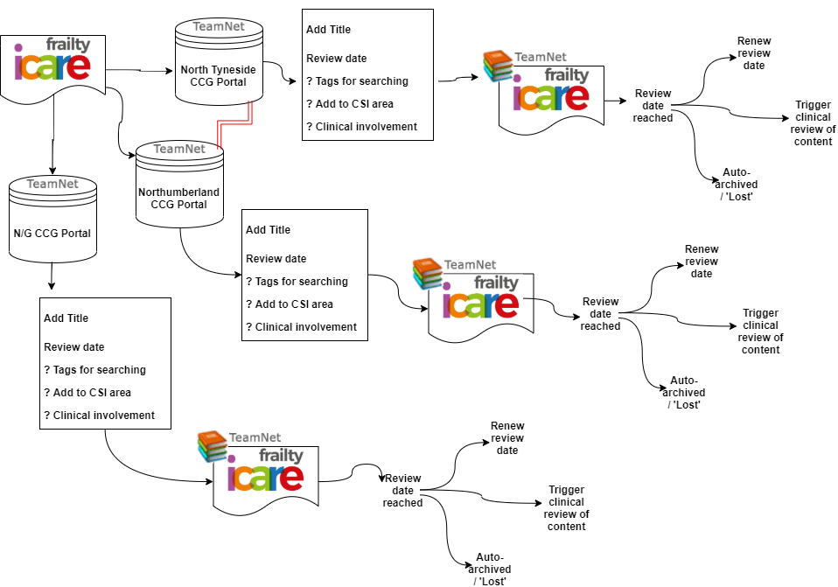
Proposed model for sharing documents within the ICP

